

3S IT Solutions Virtualisation Project

Project Charter v1.05.

AUTHORS: Darrin Hodges,
Reynaldo Suarez,
Nick Bronnikov.
SUBJECT: Project Charter.
TEACHER: Francisco Palma.
Table of Contents

1. Document Summary 3
1.1 Document History 3
1.2 Document Purpose 3
1.3 Document Audience 4

2. About 3S IT Solutions 4
2.1 Corporate Aims 4
2.2 Mission Statement 4
2.3 Vision Statement 5
2.4 Products and Services 5

3. The Client – Sydney Institute TAFE 5

4. Current situation for St George TAFE 5

5. Problem analysis for St George TAFE 6
5.1 Why the problem exists 6
5.2 Implications of the problem 6
5.3 Results if the problem is not fixed 6

6. Proposed Solution – Objectives and Scope 6
6.1 The major objectives to be accomplished by this project 7
6.2 Scope of the project 7
6.3 Features of proposed model 7
6.4 Graphic representation of solution – conceptual model 8

7. Project stakeholders 9

8. Project deliverables 9

9. Glossary 9

10. References 10

Document Summary

Document History
Date | Revised By | Changes Made | Version
11/08/2010 | Darrin Hodges | Initial Document | 1.00
12/08/2010 | Reynaldo Suarez | Sections by Reynaldo and Nick added. | 1.01
16/08/2010 | Darrin Hodges | Reformatted document to TAFE style guide. | 1.02
17/08/2010 | Darrin Hodges | Finished formatting, remade conceptualization graphic | 1.03
18/08/2010 | Darrin Hodges | Removed header/footer from index page. Fixed syntax and typing errors. | 1.04
04/09/10 | Darrin Hodges, Reynaldo Suarez | Implemented missing document standards. Revised sections supplied by Reynaldo. | 1.05
Sections by Darrin Hodges:
- About 3S IT Solutions
- Introduction of the client
- Description of current situation of the client.

Sections by Reynaldo Suarez:
- Problem analysis
- Proposed solution

Sections by Nick Bronnikov:
- Stakeholders
- Outline of project deliverables.

1.2 Document Purpose
The 3S IT Solutions project charter provides an overall view of the work to be completed. This document defines who the solution provider is, who the client is, the client’s problem and a conceptualized view of the solution. As an overview document, this charter will provide a reference point to ensure all elements of the project and all those involved in the project work cohesively to provide a viable solution to the stated problem.

1.3 Document Audience

This document will serve as a reference and planning point for the 3S IT Solutions team and project overview by the client (TAFE) represented by Francisco Palma. Participants will also include the QA co-ordinator, security co-ordinator, hardware manager, software manager and lead designer.

About 3S IT Solutions

3S IT Solutions is a dynamic IT solutions team dedicated to providing reliable, robust and high performance solutions to your IT problems.

Project Members | Role(s)
Darrin Hodges | Team leader, Security co-ordinator, Standards co-ordinator, Hardware manager.
Reynaldo Suarez | Deputy team leader, Recording secretary, QA co-ordinator, Presentation co-ordinator.
Nick Bronnikov | Lead designer, Network administrator, test co-ordinator, implementation co-ordinator.

2.1 Corporate Aims
3S IT Solutions aims to:
- Grow 3S whilst still providing personal service to customers.
- Keep up to date with technical developments to provide the very latest technological solutions to customer problems.
- Provide ongoing support for delivered projects.
- Deliver projects on time and on budget.
- Provide a work environment to attract the best and the brightest people.
- Ensure ROI for customers.
- Maintain high ethical and professional standards when dealing with customer’s information.

2.2 Mission Statement
Our goal is to help our customers streamline their IT infrastructure by providing the most efficient and cost effective solutions available. Once a 3S solution is in place, 3S provides the highest levels of support to ensure high availability and reliability of your IT investment. 3S take care of your IT needs so you can take care of business.

2.3 Vision Statement

3S IT Solutions aims to provide robust cutting edge solutions to give our clients the competitive edge. 3S IT Solutions is to become the IT solutions provider of choice whether you are a small business or a large enterprise. We will provide the best solutions and best value for money for your IT investment.

2.4 Products and Services
3S IT Solutions covers a broad range of software and hardware offerings in order to best meet customers requirements. We offer installation and configuration of Windows desktops, Windows Server, Linux, Solaris and Cisco routers. 3S also provide system integration and virtualisation support as well as Internet security through configuring firewalls to suit your business needs. We can provide upgrade solutions for legacy systems and can tailor or create software solutions with our in-house development team.

The Client – Sydney Institute TAFE

Sydney Institute TAFE, St George campus.
Sydney Institute TAFE (Technical and Further Education) NSW has been providing tertiary education for over 100 years. Courses are available from certificate level to advanced diploma. The St George TAFE campus started out as the St George branch Technical School in 1886 and is now one of seven world class training facilities provided by the Sydney Institute. Over the past 100 years enrollments have grown from 300 to over 74,000 annually.
Due to a recent economic downturn precipitated by the global financial crisis, the St George TAFE IT department is looking to consolidate its aging servers using virtualisation to cut costs and prevent job losses within the department. The department wants to maintain at least a similar level of performance with the virtualised system whilst providing a seamless transition during and after the consolidation process.

Current situation for St George TAFE

The IT section of St George TAFE currently has four servers: Three Windows and one Linux. These servers consist of:

- Windows 2008 file server and domain controller, 64 bit.
- Windows 2007 Exchange server, 64 bit.
- Windows 2007 MS SQL 8 server, 64 bit.
- Linux Redhat server.
The user base consists of up to fifty concurrent users. These servers are due for upgrading, however due to budgetary constraints caused by the recent economic downturn, the college must balance the cost of upgrading four servers against retaining staff.

The college approached 3S IT Solutions to find out if the four servers can be consolidated into one server using virtualisation technology and the streamlining of their IT budget whilst retaining the existing services and staff.

Problem analysis for St George TAFE
This section is to describe what this problem is about, the implications of the problem and what the results will be if the problem is not fixed.

5.1 Why the problem exists
This project is aimed to integrate all the servers at TAFE St. George into one machine powerful enough to handle all tasks with consistent speed, security and reliability. At the moment, TAFE is running four individual servers to process all their data and networking needs which is showing problems rising on data access speed, high maintenance cost and security issues. What we are trying to achieve is to install a machine that will be proposed on the feasibility report and basically virtualizes all file, database, mail and Linux servers all into one. We intend to finish this project by the end of year 2011 with minimum funding and impact to improve the security and integrity of the whole network by using existing hardware.

5.2 Implications of the problem
Why are we making this proposal? Because the following issues may escalate to a higher level, which can be easily avoided if the proposed solution is given a chance to be implemented:
  - Complaints about speed and system performance.
  - Missing or corrupt files.
  - Unreliability of peripherals such as printers and projectors.
*As a result of the above, loss of productivity will occur.

5.3 Results if the problem is not fixed
The following points indicate how important this proposal is and the consequences if the issues are not dealt with properly.
  - Integrity and security across the network could become more vulnerable to attacks with so
many entry points into the network.
  - Lack of reliable speed across the network.
  - Higher maintenance costs.
  - More servers mean more downtime and less effective information handling.

Proposed Solution – Objectives and Scope
This section describes the major objectives to be accomplished by this project, the scope of the project, features of proposed model and the graphic representation of the solution.

6.1 The major objectives to be accomplished by this project
To integrate all current servers into one powerful machine that can handle data transfer and accessibility with better performance, speed and low maintenance cost without sacrificing either security or network integrity.

6.2 Scope of the project
Covered | NOT Covered
Physical replacement of the server and replacing it with a new one | Will commence training staff after installation
Servers, firewall, router, backups setup | Ongoing technical support will not be provided unless agreed upon or requested by the stakeholders
Will commence training staff after installation | Hardware warranty concerns will be issued directly to the third party vendor

6.3 Features of proposed model
The following points will give us an overview on the key features of the proposed system:

- Reduced costs of hardware and maintenance.
- Making management easier because of a single point of control.
- Safely run multiple applications on a single system.
- Better performance due to limited downtime, proper allocation of IT resources and avoiding repetitive configuration and maintenance tasks.
- Increased security for better performance as well as state of the art counter measures against attacks, malicious programs and unauthorized access.
- Increased uptime reduced costs and improved productivity via advanced server management capabilities.

- Simplified management including around-the-clock remote management capability.

- Improved server availability by continuously monitoring your system and notifying you of potential system failures or changes.

- Advanced power notification, control and monitoring to help achieve lower heat output and cooling costs.

- Provides increased network throughput and redundancy with efficient slot-saving integration.

- Allow the server to continue operating in case of fan, power supply and hard disk drive failure.

- Replace components without taking your server offline or out of the rack.

6.4 Graphic representation of solution – conceptual model
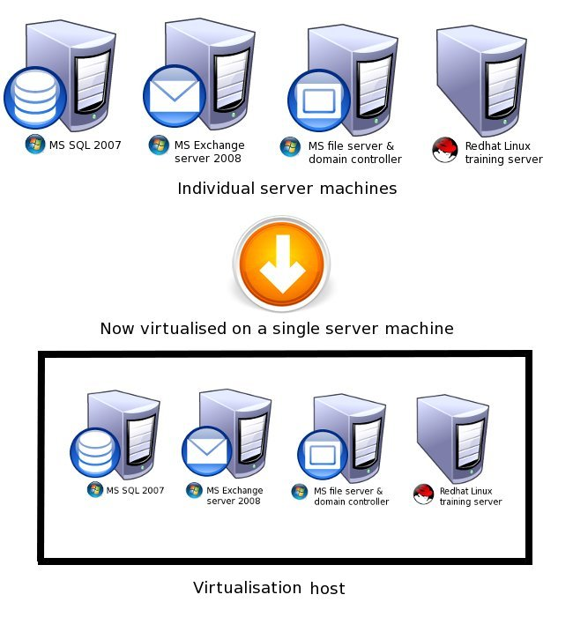

Project stakeholders
The proposed project will positively reflect on Internal TAFE Stakeholders as well as external. Internal would be all people who have access to the file system, database and mail server on site, i.e. students, teachers and all staff members who work there.
External Stakeholders would be again students who study remotely, teachers who must be able logon at any time to assist online students and staff. As for staff it could be head office members or remote communities/campuses whose studying program is based on the main campus study guide.
- Students, teachers and staff members must be able to seamlessly access the email/web server and file system at any time. Online students must be able to submit their assignment any time during studying period remotely and teachers must have access to the system to collect students work and upload new tasks.
- The new project will improve service reliability and performance, i.e. their web/mail server will provide higher access speed and availability as well as better security against loss of data.

Project deliverables
The project outcome will be an installation and configuration of a new server which will be chosen not only to handle the needs of stakeholders but deliver a better system performance, reliability with a lower maintenance cost.
Estimated project delivery dates will be the end of 2011.

Glossary

Red Hat - has become associated to a large extent with its enterprise operating system Red Hat Enterprise Linux and with the acquisition of open-source enterprise middleware vendor

Virtualization - sufficiently complete simulation of the underlying hardware to allow software, typically a guest operating system, to run unmodified

Downtime - is used to refer to periods when a system is unavailable

Server - a server application, operating system, computer, or appliance

Firewall - a technological barrier designed to prevent unauthorized or unwanted communications between computer networks or hosts

Router - is a device that interconnects two or more computer networks, and selectively interchanges packets of data between them

References

Project Charter Example for Every Project Manager - http://www.brighthub.com/office/project-management/articles/5159.aspx
Routers - http://en.wikipedia.org/wiki/Router

